Run “nzstop” command to close netezza service

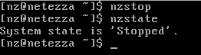

Run “nzconvertsyscase -u -D /nz/data -K /nz/kit” to resum netezza config

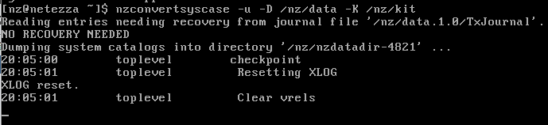

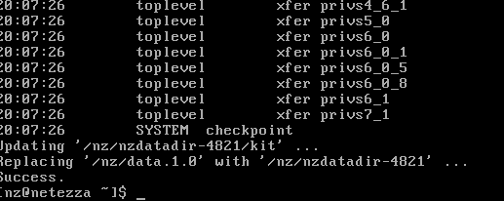

Run “nzstart” to start netezza service



Run “show system default passwordpolicy;” to show password policy

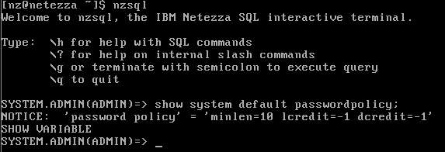

Run “create user Ben with password ‘syscom111’;” to verification password policy，but not working

